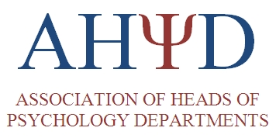 | AHPD Annual General Meeting  13th October 2023  Regent's Conferences & Events  Inner Circle  London  NW1 4NS

Main Meeting

10am – Tea and Coffee

10.30am - Welcome and Apologies
To receive: welcome from Chair Professor Almuth McDowall and apologies for absence from members

Minutes of the last meeting
To receive: The minutes of the previous meeting

Matters Arising
To note: Any matters arising from the minutes not covered elsewhere on the agenda

QAA Consultation
To receive: an update on the current QAA consultation – Dr Ailsa Crum - QAA

REF Consultation
Chair to give an update on the AHPD response

British Psychological Society update on activities ??
To receive: an update from Debra Malpass from the BPS

Chair’s Report
To receive: a report from the Chair

Secretary’s Report
To receive: a report from the Secretary

Treasurer’s Report/Auditor’s Report
To receive: a report from the Treasurer

AHPD Representatives’ Reports
To receive: Reports from AHPD representatives

Issues of concern to heads

Any Other Business

12.30 Lunch

1.30-3.30 Workshop

1.30pm-3.30pm – Mentoring Workshop led by Professor David Clutterbuck – founder and practice lead of Clutterbuck Coaching and mentoring

